

12 PHYSICS

SPECIAL RELATIVITY

RELATIVITY

Moving Through Spacetime

People are very used to moving through time and space. They are moving through time at the rate of 24 hours every day, but are not moving through space (unless they are in a train).

If a person takes a fast trip to the other side of the world, they have moved through space as well as time.

Einstein’s radical idea was that travel through space and travel through time are interrelated. In a sense, the faster a person travels through space, the less they travel through time. It is as though the person moves through what Einstein called spacetime at a constant rate, but the amount of space and the amount of time depend on who measures them.

If someone on Earth observes a space traveller, it turns out that the measurements of her time elapsed and distance travelled do not agree with her measurements. Her time is going more slowly than ours. However, the traveller sees that our clocks are going slow. Who is right?

The answer is that both are. Time and space are relative. But that is what Einstein’s theory of relativity is all about.

Frames of reference

Velocity is always measured relative to some particular co-ordinate system or frame of reference.

If you make measurements from a frame of reference that is moving at a constant velocity, then any measurements of change in velocity will agree with those made by observers in any other constant-velocity frame of reference.

Frames of reference that move with a constant velocity are called inertial frames of reference.

Example

A car is moving at 60 kmh⁻¹ relative to the ground. The assumption is that the car's velocity is measured by a radar gun that is at rest relative to the road.

If the reading is made by a radar gun mounted on a police car following behind at
50 kmh⁻¹ relative to the road, the same car is only travelling at 10 kmh⁻¹.
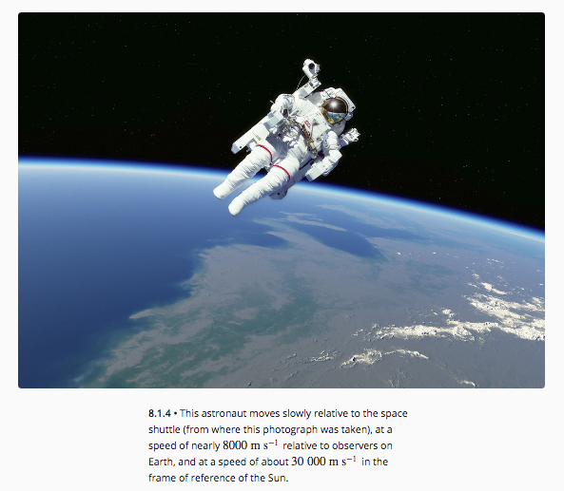

According to Galileo's equations and Newton's laws, the velocity of objects can be calculated relative to any frame of reference as long as the velocities of the frames of reference are known.

Example

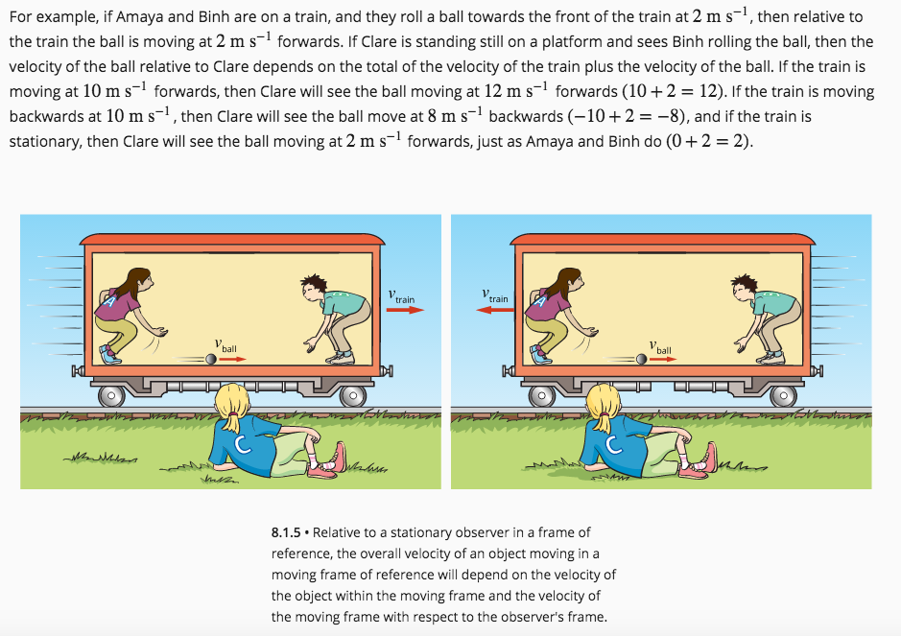

SPEED OF LIGHT

The speed of light is one of the most accurately measured constants in physics and its value has been determined very precisely by many different methods.

The accepted value of the speed of light in a vacuum is now:

c = 2.99792458 x10⁸ ms^{–1}

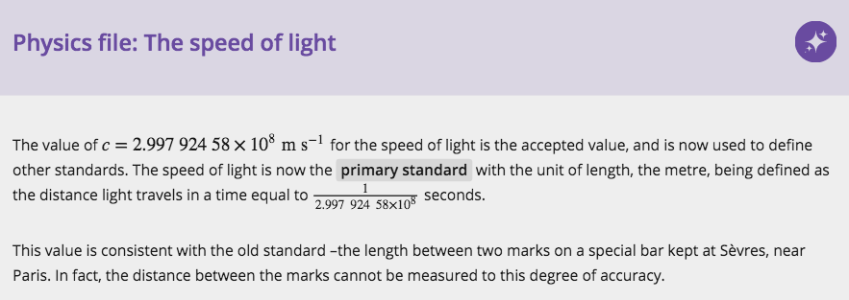

James Maxwell, working in 1864, derived the speed of light from a mathematical analysis of the propagation of electromagnetic waves.

He took the concept of electric and magnetic fields and worked with them to produce a mathematical description that encompassed all known electromagnetic phenomena. This description can be summed up in four famous equations, referred to as Maxwell's equations.

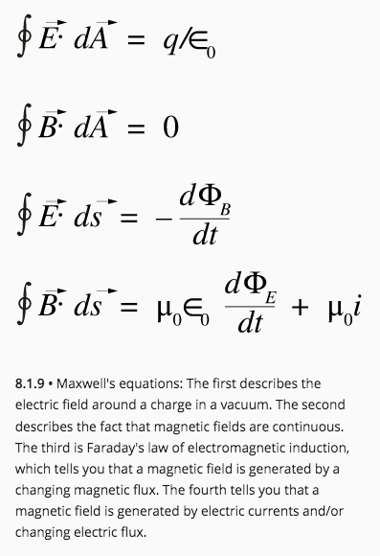

He found that his equations could be used to predict that changing perpendicular electric and magnetic fields could self-propagate through space at a speed given by the fundamental electric and magnetic force constants.

where ε_{o} = the electric permittivity of a vacuum.
μ_{o} = the magnetic permeability of a vacuum.

This speed turned out to be 3.00 × 10⁸ ms⁻¹

Maxwell faced a conundrum, however. His derivation of this speed showed that its value depended only on the two constants for the strength of the electric and magnetic force fields near charges or currents. There was no indication that it should be any different if, for example, the source of the light was in motion.

i.e. Speed of light is constant in all reference frames.

There was no indication that it should be any different if the source of the light was in motion.

What was surprising, though, was that there appeared to be no allowance for the speed of the 'receiver' of the light.

e.g. If you run towards a ball thrown at you, the speed of the ball, relative to you, is greater than if you stand still.

Similarly, if a person is moving towards a source of sound, the speed of the sound (the product of the measured frequency and wavelength) will be the sum of the speed of sound in the medium and the speed of the person.

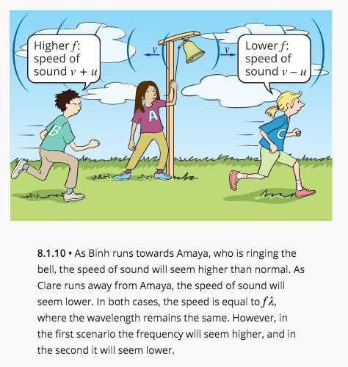

Maxwell's equations refused to make any allowance for the motion of the observer of light waves. Whatever the speed of the observer, the measured speed of light is 3.00 ×10⁸ ms⁻¹ - something quite against all the known laws of physics.

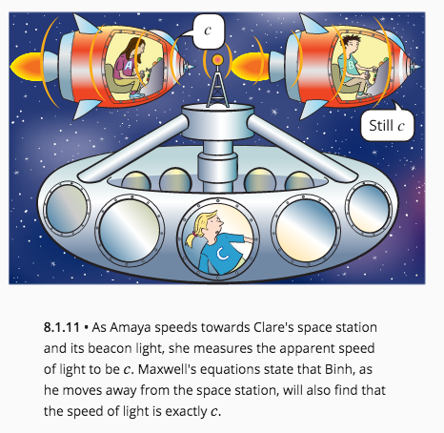
The Michelson-Morley Experiment

In the 1880's, Albert Michelson and Edward Morley set up a device known as an interferometer, which was able to measure the very small differences in the time taken for light to travel in two mutually perpendicular directions. They were able to rotate the whole apparatus and hoped to detect the small difference that should result from the fact that one of the directions was to be the same as that in which the Earth was travelling and the other at right angles. However, they found no difference.

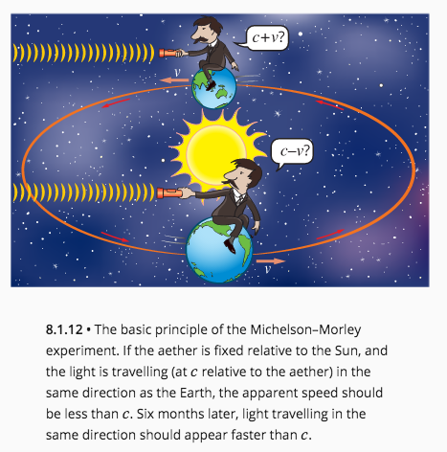

Six months later, when the Earth would have to be travelling in the opposite direction relative to the light coming from the Sun, there was still no difference in the measured speeds.

EINSTEIN

Einstein was the archetypal theoretician - the only significant experiments he ever did were thought experiments, or ‘Gedanken’ as they are called in his first language (German). Many of his Gedanken experiments involved thinking of situations that involved two frames of reference moving with a steady relative velocity. Newton had referred to these as inertial frames of reference, as the law of inertia applied within them, but not within frames that were accelerating.

He stated that all inertial frames of reference must be equally valid, and that the laws of physics must apply equally in any frame of reference that is moving at a constant velocity. A consequence of this is that there is no physics experiment you can do, completely within a particular frame of reference, to tell that you are moving.

e.g. As you speed along in a Gedanken train with the blinds down, you cannot measure your
speed, at least not without peeking out the window, or connecting something to the
wheels, which are in contact with the outside frame of reference.

You can tell if you are accelerating easily enough: just hang a pendulum from the
ceiling. However, the pendulum will hang straight down if your velocity is constant,
whether you are travelling steadily at 100 kmh^{–1} or are stopped in the station.
THE SPECIAL THEORY OF RELATIVITY

Paradox - how could two observers travelling at different speeds see the same light beam travelling
at the same speed?

Einstein put forward two simple postulates.

• The principle of relativity states that no law of physics can identify a state of absolute
rest. (In other words, no single inertial frame of reference is better than any other.)

• The speed of light will always be the same no matter what the motion of the light source
or observer.

Newton’s laws are based on the idea that space and time are how they seem to a person on Earth - constant, uniform and straight. Space is like a big set xyz axes that always remain mutually perpendicular, and in which distances can be calculated exactly according to Pythagoras’s rule. In this space, time flows on at a constant rate that is the same everywhere.

Einstein realised that the assumptions Newton made may not in fact be valid, at least not on scales involving huge distances and speeds approaching that of light. The only way in which his postulates can both be true is if space and time are not ‘absolute’.

Einstein’s Gedanken Train

Einstein discussed a simple thought experiment to illustrate the consequences of accepting the two postulates. It involves a train moving at a constant velocity. Angela and Bill have boarded Einstein’s train to help us with our experiments and Clare is still (stationary) outside on the platform.

This train has a flashing light bulb set right in the centre of the carriage. Angela and Bill are watching the flashes of light as they reach the front wall and back walls of the carriage, respectively. They are not surprised to find that the flashes reach the front and back walls at the same time.

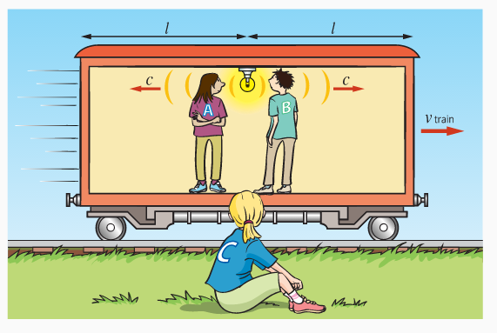

Outside, Clare is watching the same flashes of light. Einstein’s interest was in when Clare saw the flashes hit the end walls.

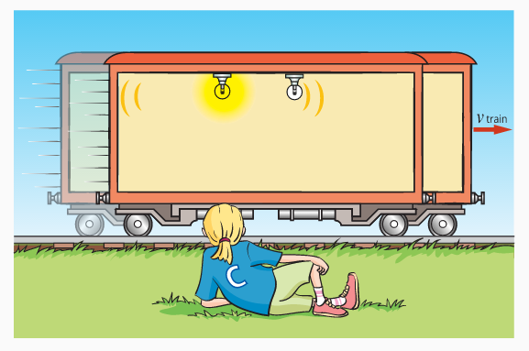

The light has to reflect from the walls and then travel to Clare before she can ‘see’ it hit the wall, but the simplifying assumption made is that she makes the appropriate calculations to determine when the light ‘actually’ hit the walls - she ignores the look-back time.
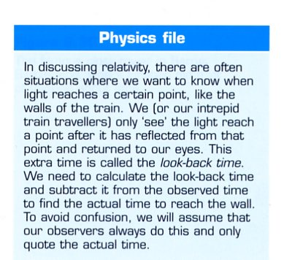
If Clare sees the light travelling at the same speed in the forward and back direction, she will see the light hit the back wall first. This is because that wall is moving towards the light, whereas the front wall is moving away from the light and so the light will take longer to catch up to it.

This is all against the principles of Newtonian physics.

• Angela and Bill saw the light flashes reach the ends of the carriage at the same time.

• Clare saw them reach the walls at different times.

The idea that two events that are simultaneous for one set of observers are not simultaneous for
another is a conundrum.

(Remember - Clare did not see the flashes at different times because of some sort of look-back time delay - that has been taken into account.)

This is often referred to as a lack of simultaneity - simultaneity means that a person would normally expect that, if one set of observers see two events happen simultaneously, they would expect any others to also see them simultaneously.

Simultaneity And Spacetime

How is it possible that two events that are simultaneous to one set of observers are not simultaneous to another?

Einstein said that the only reasonable explanation for this is that time itself is behaving strangely.
The amount of time that has elapsed in one frame of reference is not the same as that which has elapsed in another.

Because time (which has one dimension) seems to depend on the frame of reference in which it is measured, and a frame of reference is just a way of defining three-dimensional space, clearly time and space are somehow interrelated. Physicists call that four-dimensional relationship - spacetime.

Special relativity is all about spacetime.

This was a profound shock to the physicists of Einstein’s time. Many refused to believe that time was not the constant and unchanging quantity that it had always been assumed to be, and certainly always seemed to be.

And to think that it might ‘flow’ at a different rate in a moving frame of reference was too mind-boggling for words. That could mean that if a person went for a train trip, their clocks would go slow and they should come back younger than those who stayed behind.
This is what Einstein postulated, but younger by something much less than a microsecond - rather difficult to notice.

CONSEQUENCES OF SPECIAL RELATIVITY

There are three consequences of Einstein’s special theory of relativity.

• Time Dilation

If Einstein is correct that the speed of light is constant for each observer, regardless of their frame of reference, then one can compare the period of time for a light event in two frames of reference.

Example

Angela and Bill are travelling in a Gedanken space ship, while Clare observes from a space station. By observing a photon travelling from the light bulb in the space ship to the floor, one can determine the time taken for the event by dividing the distance travelled by the speed of light.

Angela and Bill see the light travelling the height of the space ship at the speed of light, so:

At the same time Clare, watching from the space station, sees the same event. The photon travels from the light bulb to the floor at the speed of light, but during that time the space ship has moved forward some distance determined by the velocity of the space ship and the period of time for the event. So Clare sees the photon travel at an angle to the ground.

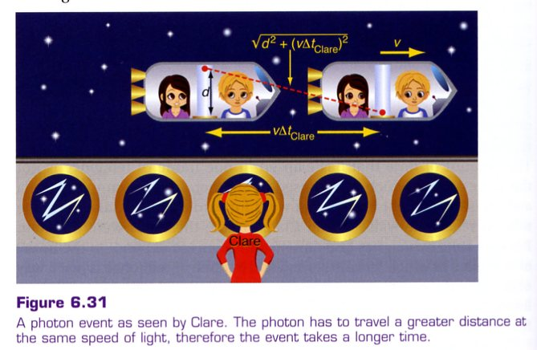

The time that the photon takes to travel from the bulb to the floor is:

The extra distance that the photon must travel in Clare’s frame of reference means that the same event takes a longer period of time to occur.

In fact, every event observed in Angela and Bill’s frame of reference by Clare will occur over a longer period of time - the time taken for the second hand on Angela’s watch to move will take longer, the time it takes for Bill to draw a breath will take longer.

The faster the space ship travels, the longer an event takes to occur, when viewed from a stationary frame of reference.

If Angela and Bill were riding a photon, how long would an event take when travelling at the maximum speed possible - the speed of light? The answer is - forever!

They would appear to Clare to be frozen in time, for Angela and Bill everything else would also appear frozen in time, and it would appear to take no time to travel from one end of the Universe to the other.

Time dilation is when an event is timed in an inertial (constant non-zero) frame of reference
by an observer in another inertial (stationary) frame of reference, and it will occur over a
longer period of time than it does for the same event timed by an observer in the moving
frame of reference.

To generalise Einstein's equation for time dilation, the symbol t is used to represent the dilated time that a stationary observer measures using a stationary clock, for an event that the observer sees occurring in a moving frame of reference. The symbol Δt is also used to represent this dilated time measured by a stationary observer. The symbol t₀ is then the time that passes on the moving clock, which is also known as the proper time. Proper time can also be represented by the symbol Δt′ .

The factor that the proper time is multiplied by is given the symbol γ, so that:

t = γt₀

where

The physicist H. A. Lorentz first introduced the factor γ in an attempt to explain the results of the Michelson–Morley experiment, so it is often known as the Lorentz factor.

Example 1

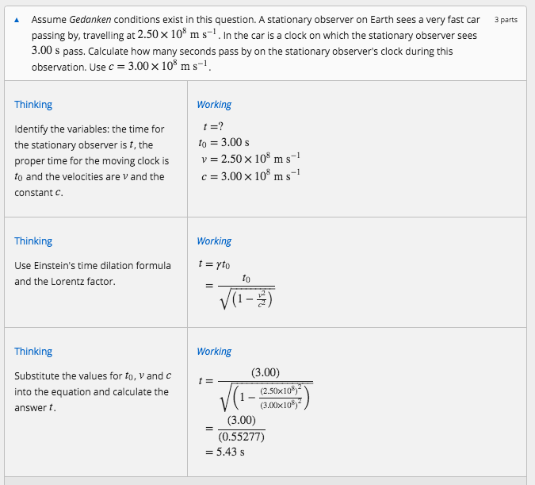
For normal speeds, the Lorentz factor is essentially 1.000. As the object approaches relativistic speeds, the factor becomes very significant.

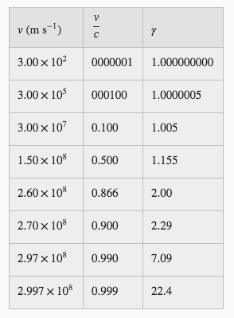

Example 2 - Long-lived Muons

In the Earth's atmosphere, high-energy cosmic rays interact with the nuclei of oxygen atoms 15 km above the surface of the Earth to create a cascade of high-velocity sub-atomic particles.

One of these particles is a muon, which is unstable.

The mean lifetime of a stationary muon, as measured by an atomic clock, is 0.000 002 196 s
(2.196 μs). The muons created by cosmic radiation typically travel at 99.97% of the speed of light, so at this speed, Newtonian physics would predict that a muon would travel about 659 m.

s = vΔt
= (0.9997)(3×10⁸)(2.196×10⁻⁶)
= 659 m

Given that, after 10 lifetimes, you can expect there to be essentially no muons remaining, then after a distance of 6.58 km, or at a height of about 8.42 km above the surface of Earth, you would expect that no muons would be detected.

However, you find that muons created by cosmic radiation are actually detected at the surface of the Earth. This means that the fast-moving muons have existed for a much longer period of time than they should have. A muon that strikes the surface would have existed at least 22.8 times its predicted lifespan as a stationary muon.

From the table above, the muon would be travelling at least 0.999c - hence it exists for longer than its normal mean ifetime.

Time dilation provides the explanation to this unusual observation.

Length Contraction

In the previous section, a photon travelling from the top of the space ship to the floor was used to compare the period of time for an event. It was deliberately set up in the spaceship so that this light path, of distance d, was perpendicular to the velocity. The reason for this was that we could expect distances in this perpendicular direction to be unaffected, but this may not be the case for distances in the direction of travel.

Einstein showed that while perpendicular distances are unaffected, relative motion affects lengths in the direction of travel.

Einstein showed that as a person observes a fast-moving object, its length or the distance it travels in a certain time, will appear shorter than the distance seen when the object is stationary in the observer's reference frame.

It will be shorter by the same factor by which time appears to be extended and so Clare would see the length of the space ship contracted when compared to the length as measured by Angela and Bill.

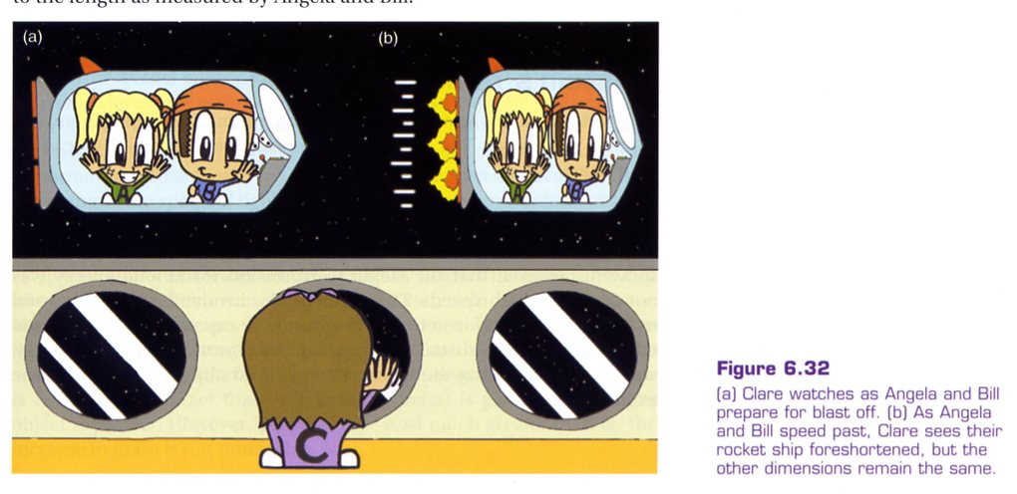

Remember that length contraction occurs only in the direction of travel, not in any perpendicular direction. To Clare, Angela and Bill’s spaceship will appear foreshortened, but its width and height will remain unaltered.

These two simple notions - length contraction and time dilation - are at the core of the special theory of relativity. Together they tell Physicists about spacetime - the four-dimensional world that humankind inhabits.

Einstein's length contraction equation shows that an object with a proper length of l₀, when measured at rest, will have a shorter length l, parallel to the motion of its moving frame of reference when measured by an observer that is in a stationary frame of reference.

Length contraction can be represented as:

This becomes:

Example

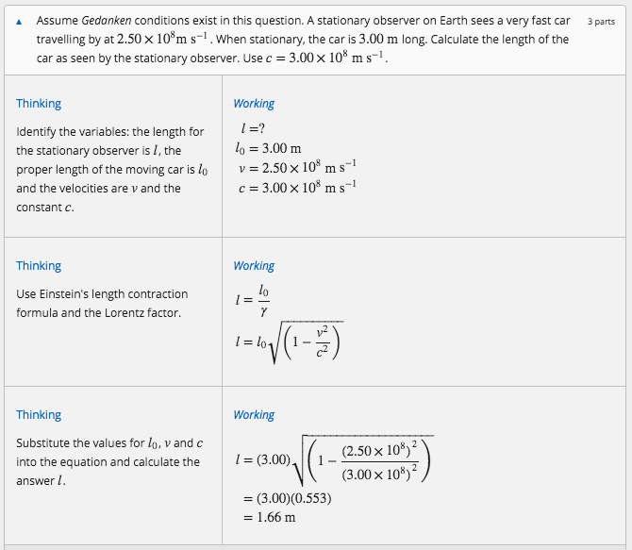

Relativistic Mass and Momentum

Calculations involving time and distance get a bit rubbery when one considers relativistic effects like time dilation and length contraction. It would not be surprising, therefore, to hear that momentum also displays relativistic effects.

If a rocket ship is travelling at 99% of c, why can’t it simply turn on its rocket motor and accelerate up to 100%, or more, of c?

A full answer to this question was not given in Einstein’s original 1905 paper on relativity. Some years later, he showed that as the speed of a rocket ship approaches c, its momentum increases as one might expect, but this is not reflected in a corresponding increase in speed.

While the force of the rocket engine increases the momentum, near the speed of light the increase in momentum results in smaller and smaller increases in speed. So no amount of impulse can accelerate the rocket ship to the speed of light.

One interpretation of this strange behaviour of momentum is that it appears that the inertial mass of the rocket ship is increasing.

Although Einstein preferred to stay with relativistic momentum, it is helpful to think in terms of the mass of the rocket ship increasing as its speed approaches c.

Hence, in terms of Newton’s law, one can simply say that as the speed increases, the force required to produce a given acceleration increases towards infinity, because the mass approaches infinity.

Thus, no matter how much force is applied or work done, a rocket ship (or anything else) can never reach the speed of light. In fact only things without mass can travel at the speed of light, like photons.

The relativistic momentum is given by:

p = γp₀

This becomes:

Example

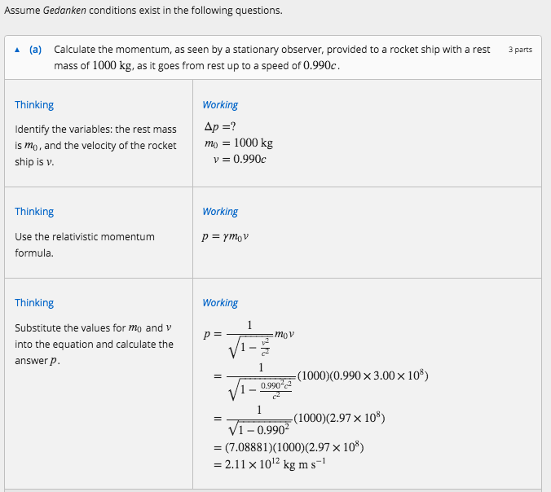

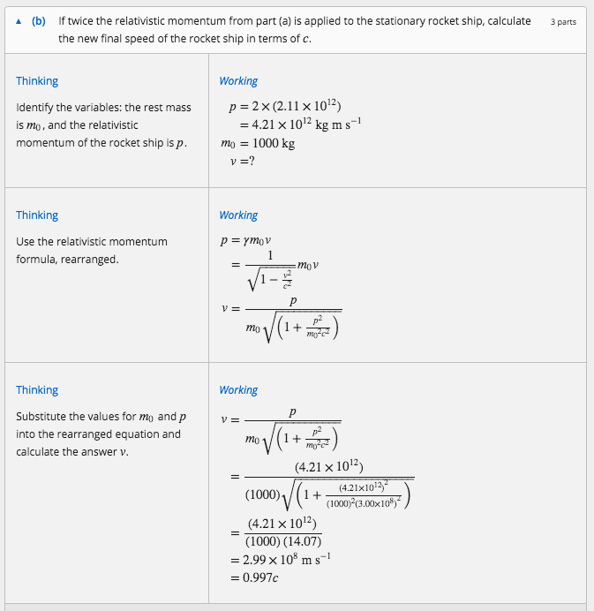
Relativistic Addition of Velocities

No two objects can have a relative velocity greater than c.

e.g. A spacecraft moving at 0.9c fires a missile at 0.8c forwards and relative to it.

According to classical Physics, a stationary observer sees this as 1.7c, which is impossible.

Velocities must transfornm according to the Lorentz transformation, leading to a non-intuitive result called Einstein velocity addition.

(See Ch. 8.4 - Relativistic addition of velocities.)

Solution to the "problem"

Consider two observers in relative motion to each other and both are observing the motion of the missile.

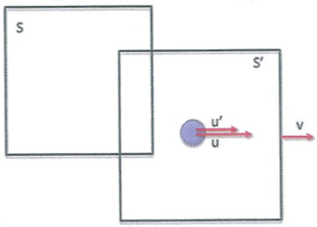
u' = velocity of missile in S'
frame
v = velocity of moving
reference frame
S' = moving reference frame
S = stationary reference frame
u = velocity of missile relative
to S frame

The equation describing u is given by:

where u = velocity of the moving object in the statonary frame
u' = velocty of the moving object in the moving frame
v = velocity of the moving reference frame
c = speed of light

In this situation: u' = 0.8c, v = 0.9c.
i.e.

Example

Two spaceships are moving apart from each other, A at 0.7c and B 0.5c in the opposite direction. What is the velocity of A as seen by an observer in B?

Consider B as the stationary reference frame.

Take the direction of B as +ve.

v = -0.7c
u = 0.5c
u' = velocity of A relative to B

Note If the direction of A is taken as +ve, u' = - 0.889c.

The -ve sign means that A is receding from B.

The result is the same.

Einstein’s Equation

As the momentum of an object increases, so does the energy. The classical relationship between the two can be written as:

As v approaches relativistic speeds near c, the kinetic energy, as well as the momentum, will increase towards infinity.

Einstein showed that the classical expression for kinetic energy was not correct at high speeds.

The mathematics involved is beyond this course but Einstein, working from the expression for relativistic momentum and the usual assumptions about work, forces and energy,
was able to show that the kinetic energy of an object was given by the expression:

where E_{k} = the kinetic energy of an object corrected for relativistic effects (J).
γ = the Lorentz factor, which is the factor that converts rest mass to
relativistic mass.
m_{o} = the mass of an object when it is at rest in our frame of reference (kg).
c = the speed of light (3.00 x 10⁸ ms⁻¹).

Einstein’s expression can be rewritten as:

Einstein interpreted this expression as being an expression for the total energy, of the object.

E_{total} = E_{kinetic} + E_{rest}

⇒

Now as γm_{o} is equal to the relativistic mass (m), the total energy can simply be written as:

where E_{k} = ¹/₂ mv²

Einstein wondered - what is the significance of the rest energy, the m_{o}c² term?

As this energy depends directly on the mass of the object, it appears to be energy associated with mass, and so mass, he realised, was a form of energy.

Physicists now understand that this equation shows that mass and energy are totally interrelated.

Example 1

A cup of hot water is ever so slightly heavier than the same cup when cold. The difference is far less than one could possibly measure, but it is.

The heat means the molecules have more kinetic energy, and as the total energy is the sum of the rest and kinetic energy, the total energy (mc²) is greater.

This is reflected in the fact that m (relativistic mass) is greater, so a hotter object is heavier.

Since m_{o}c² is so much greater than E_{k}, the increase in mass is not noticeable.

Example 2

